






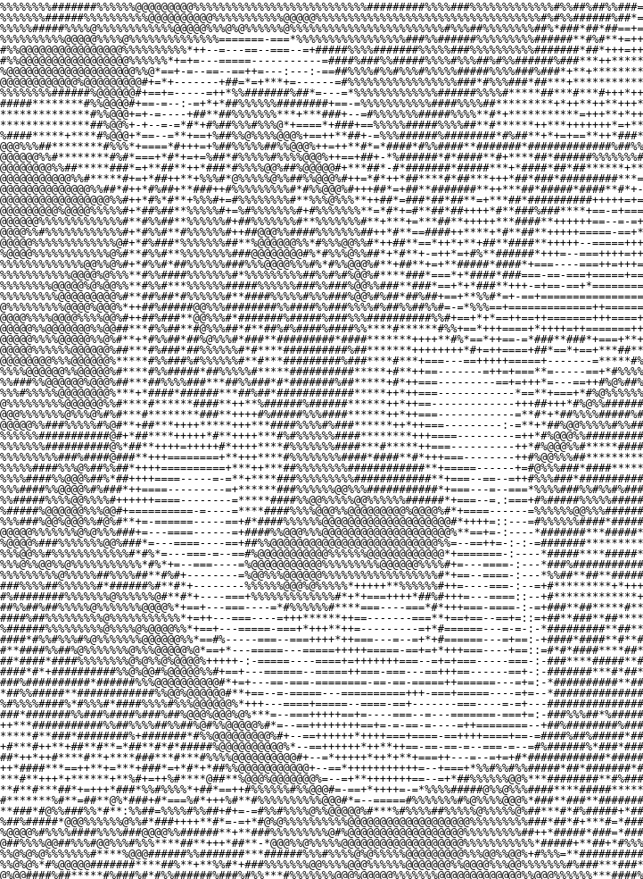
In dusk’s half-light, a serpent coils unseen,
Greed trickles like venom along hidden seams
A whisper of wealth,
A promise wrapped in silken lies,
Echoing Solomon’s warnings beneath forgotten skies.

The market murmurs in broken stanzas of desire,
A woman in midnight draped, igniting fate’s wildfire,
Her charm, a fractured lullaby that bids men stray,
Leading them on a perilous waltz toward the abyss’s grey.

In scattered rhymes that falter,
A fanged truth unfolds,
Commerce and passion, intertwined and cold,
Her eyes—riddles of ruin and a siren’s secret art,
Draw the foolhardy into shadows, leaving wisdom torn apart.

“Beware,” intoned the ancient sage in muted tones,
Not just a beauty,
But a harbinger of shattered thrones
Her melody, inconsistent as a broken chord in flight,
Invites a fatal embrace, blurring day’s edge into night.

Greed intoxicates with venomous grace,
A transient splendor that betrays its fragile base
In the labyrinth of desire,
Where reason dares not tread,
The alluring whisper of commerce leaves souls misled.

Thus, in a cascade of errant rhymes and chords astray,
The serpent and the enchantress compel us to obey
A cryptic elegy of longing, caution, and decay,
Reminding us that in beauty’s lure, ruin often finds its way.

